ENSF619

Design Document Deliverable

Group #15

Prepared by:

Yunying Zhang

Shiyu Zhou

Peiyun Zhao

November 22 2020

**Section 1 Use-case diagram**

**Section 2 Use case scenarios**

1. User selects usertype / User Login

When user opens the application, the application prompts the user to select the user type. If a user registered before, the application has his information recorded, and he will be able to proceed with usecase 2 or usecase 3. If the user is not registered before, he is an ordinary user and will proceed with usecase 3.

 Candidate Objects:

-RegisteredUser

-OrdinaryUser

-Application

Potential Operations:

* selectUsertype()

 2. Registered User browse upcoming movies

The user selects “browse movie” drop-down to browse for upcoming movies and selects a movie.

Candidate Objects:

-User

-MovieList

-Movie

Potential Operations:

* displayReservationOnlyMovie()
* selectMovie()

3. Ordinary user searches and selects a movie

The user enters the app and searches/browse for movies available, then select a movie that they wants to watch.

Candidate Objects:

-User

-MovieList

-Movie

Potential Operations:

* displayRegularMovie()
* selectMovie()

4. User selects for a theatre

After selecting a movie, the user selects the theater that is available around his/her location.

Candidate Objects:

-User

-movie

-theater

Potential Operations:

* theater.toString()
* selectTheater()

5. User selects movie show-time

After selecting the theater the user browse a list of showtime and corresponding rooms for the movie that they selected. The user then selects a showtime for a movie that he wants to watch at.

Candidate Objects:

-User

-Movie

-Theater

-Showtime

Potential Operations:

* selectShowtime()
* displayShowtimes()

6. View and select the seat

The user selects the seat that he/she wants to sit in for the movie. The application displays the GUI for all the seats in the theatre, with available and unavailable seats differentiated visually.

Candidate Objects:

-User

-movie

-theatre

-application

-seatingGUI

-seat

Potential Operations:

* selectSeat
* seatingGUI.display()

7. Purchase the ticket and check out

After the user selects the seat, the application asks the ordinary user to enter user-information, enter card-information. If the user is a registered user the previous information requested is pre-filled. When he submits the payment, the system confirms the completion of the process. The system sends the ticket and a receipt to his/her email address.

Candidate Objects:

-Ticket

-application

-User

-RegisteredUser

-OrdinaryUser

-payment

-financialInstitute

-receipt

-userType

Potential Operations:

* authenticatePayment()
* processPayment()
* emailConfimation()
* selectUserType()
* getUser()
* collectUserInformation()
* getUserInformation()
* getCardInformation()

8. User cancels the ticket

1)The user successfully refunded the ticket if he refunds up to 72 hours prior to the showtime. If the user is the ordinary user, he receives a coupon with 15% administration fee for future ticket purchase. If the user is a registered user, he will not be charged for administration fee and will get the full credit. However, the credit has a maximum of 1-year for expiration.

2)The user wanted to refund the ticket, but he was not able to successfully refund it because he is an ordinary user it is within 72 hours of the show.

Candidate Objects:

-Ticket

-Showtime

-OrdinaryUser

-RegisteredUser

-Coupon

-Cancellation

-Receipt

Potential Operations:

* refund()
* requestRefund()

9. Registered user gets charged for $20 annual fee

The registered user is requested to pay annual account fee ($20) every year.

Candidate Objects:

RegisteredUser

Potential Operations:

* payAnnualFee()

# **Section 3 List of Candidate Objects**

|  |  |
| --- | --- |
| **Candidate objects from scenarios** | **Classes implemented** |
| applicaition | LoginGUI  OrdinaryUserGUI  RegisteredUserGUI  LogisticGUI  SeatingGUI  PaymentGUI  RefundGUI |
| User  Registered User  Ordinary user | User  RegisteredUser  OrdinaryUser |
| Movie  MovieList  Theater  Showtime  Seat | MovieList  Movie  Theater  Showtime  Room  Seat |
| Ticket  Coupon  Receipt  Payment  financialInstitute | Ticket  Coupon  Receipt  Payment  FinancialInstitute |

**Section 4 Class Diagram**

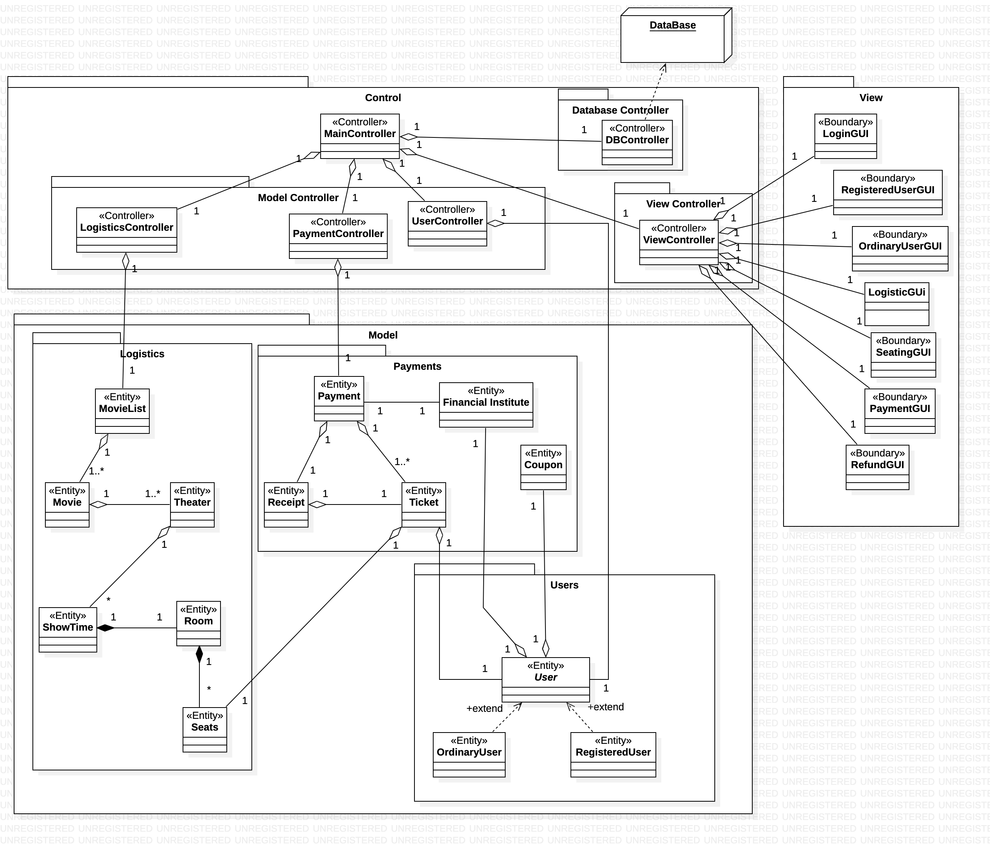

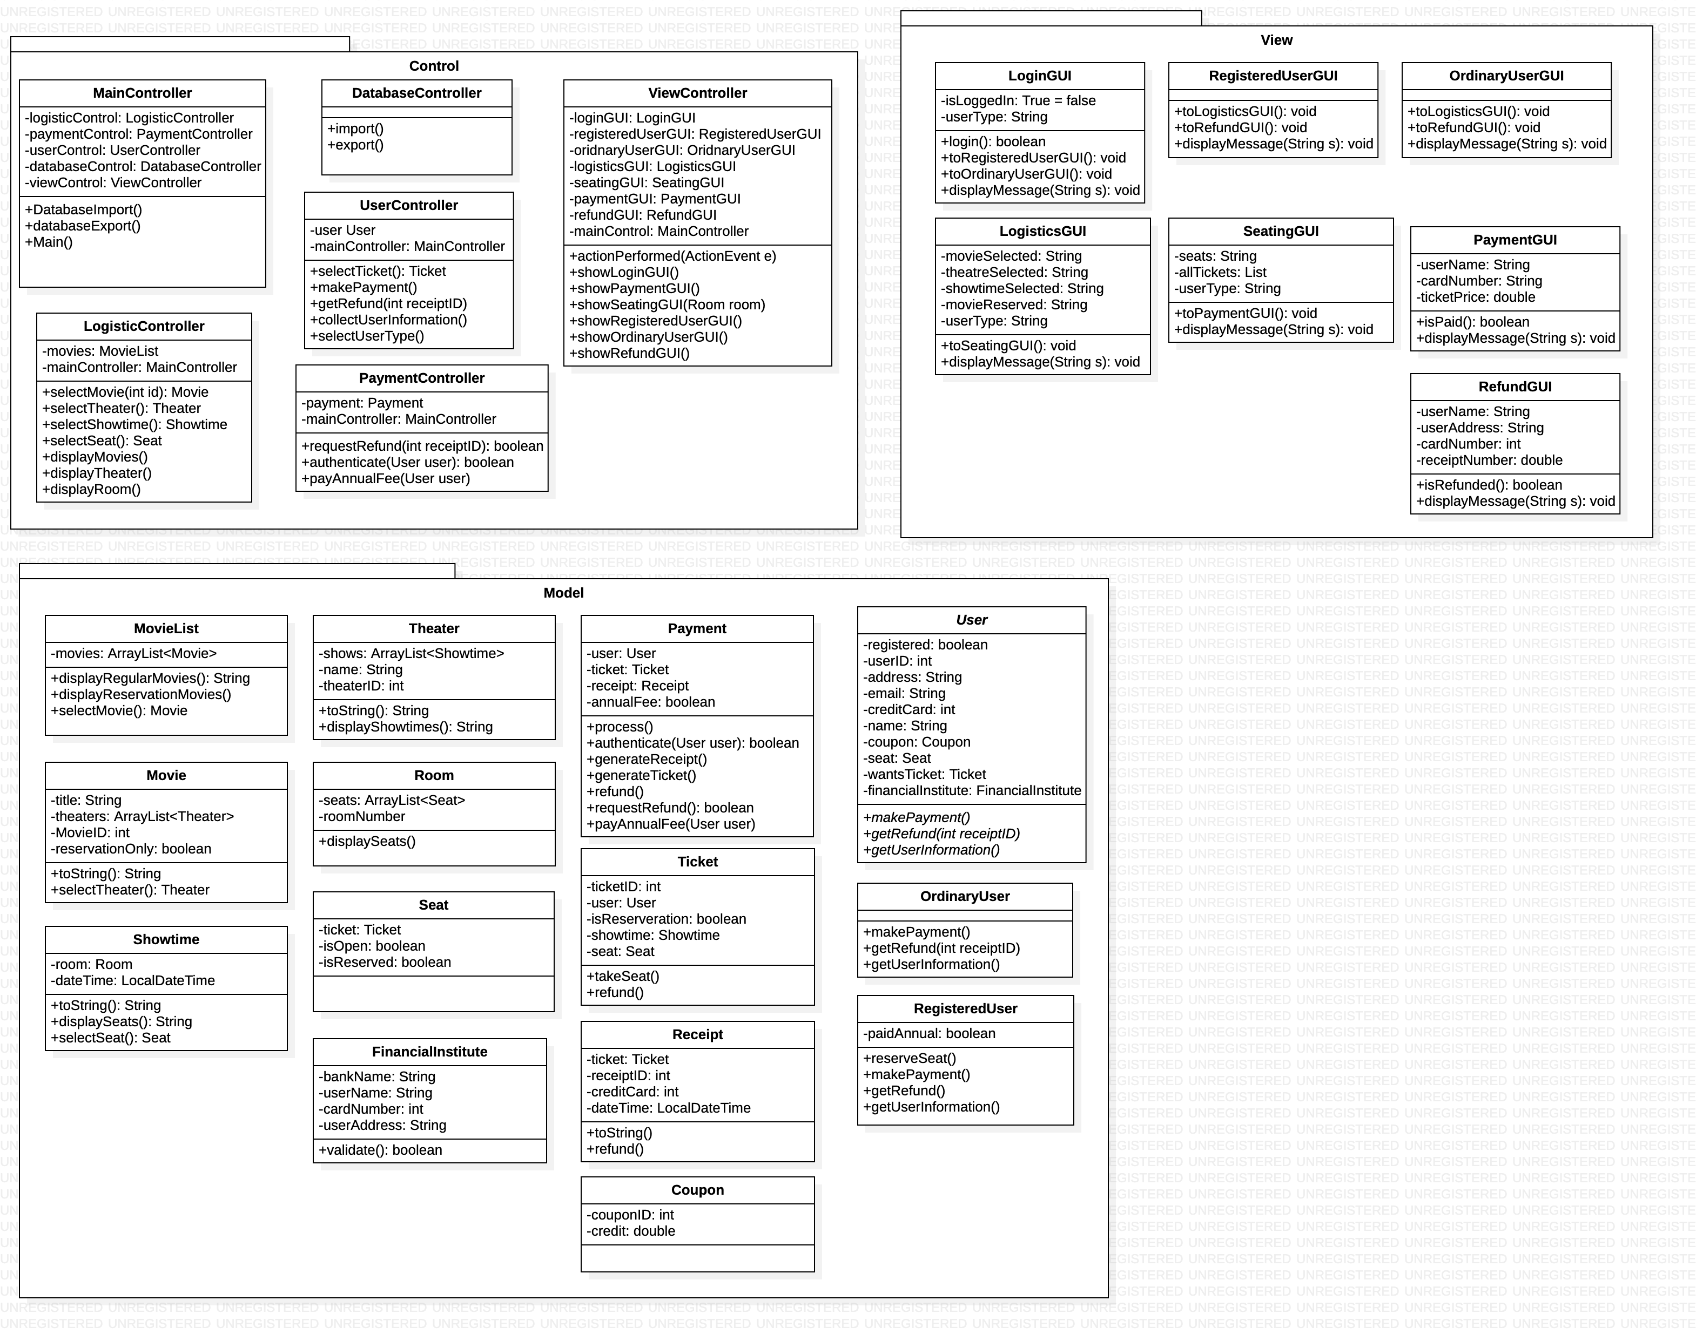**Section 5 Diagram for Classes without relationships**

**Section 6 Interaction Diagrams**

*(As we are unable to fit the diagram with bigger text, please zoom in for better readability)*

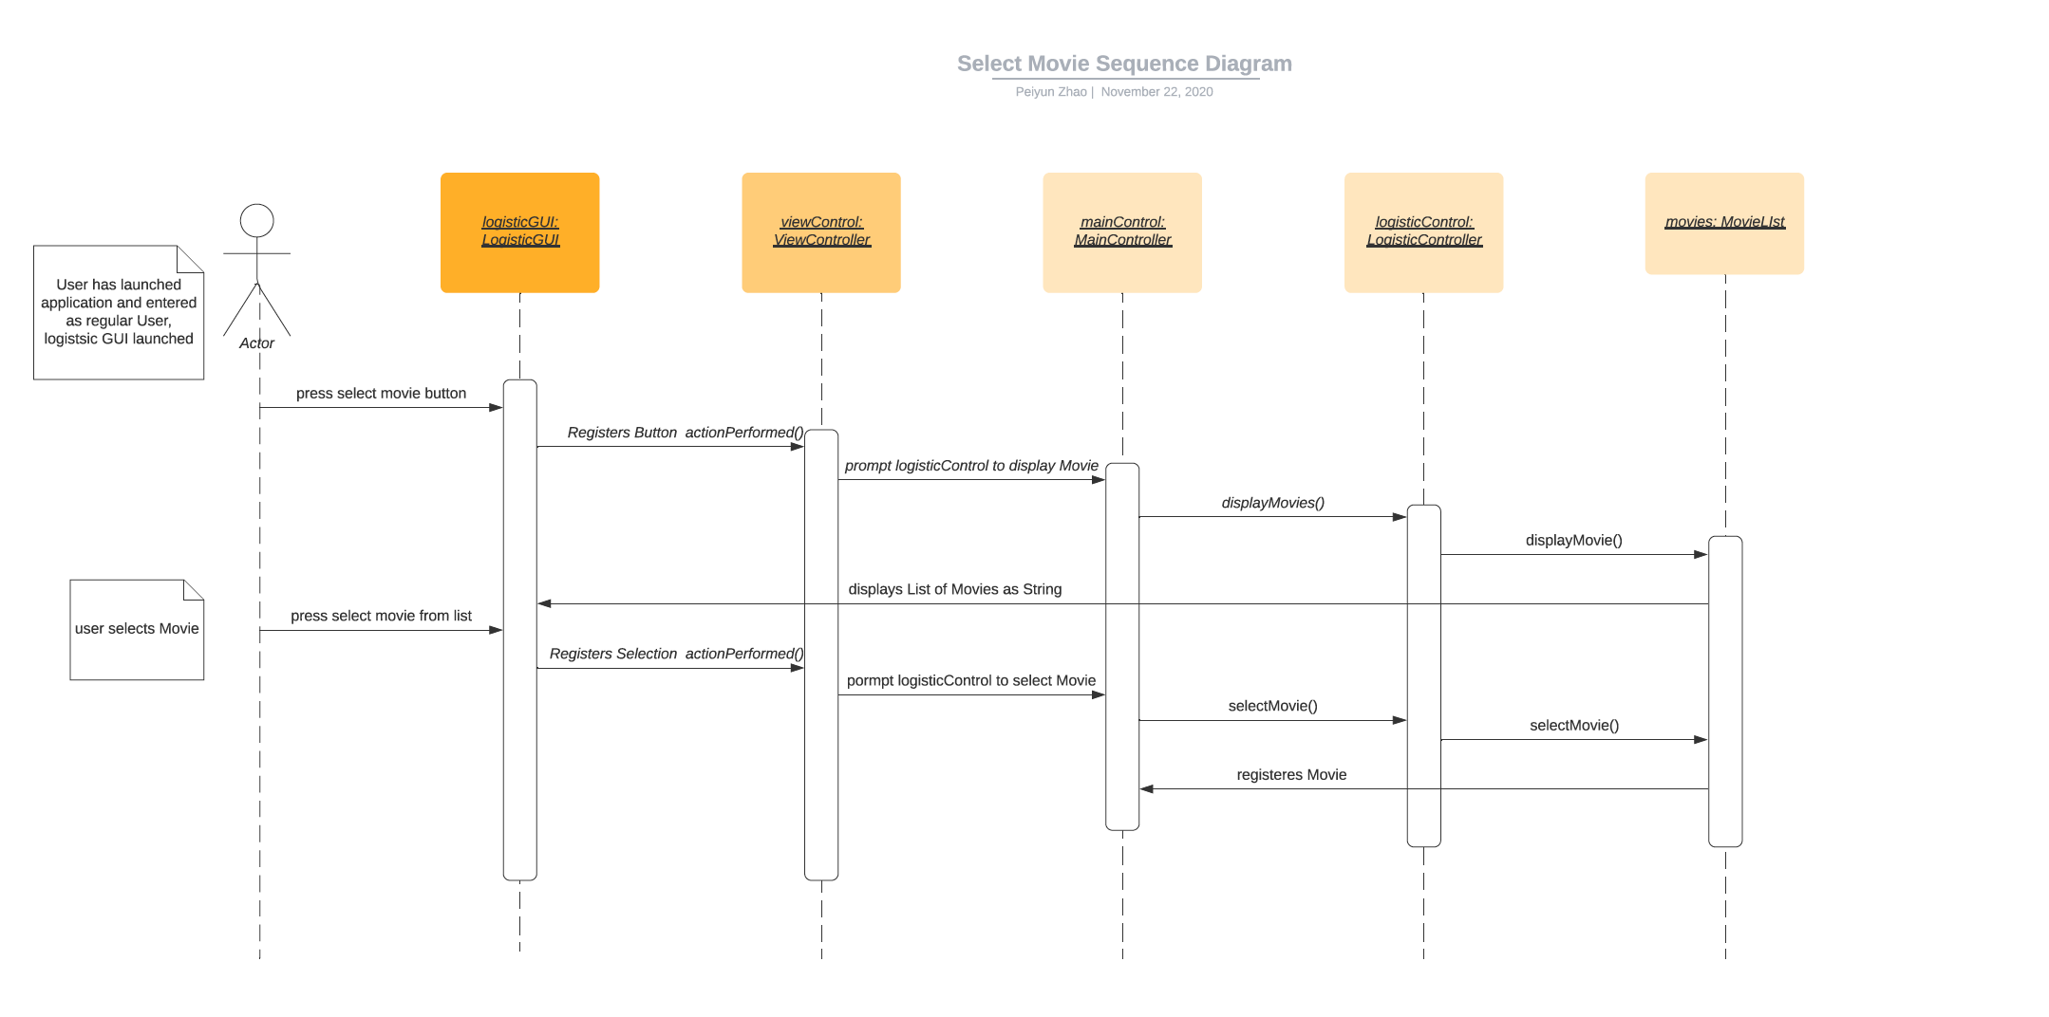Diagram #1: Prepared by Peiyun Zhao, use case: user selects a movie

Diagram #2: Prepared by Peiyun Zhao, use case: user selects a seat

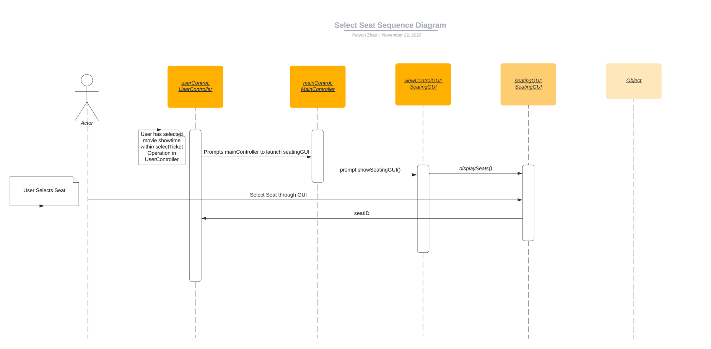

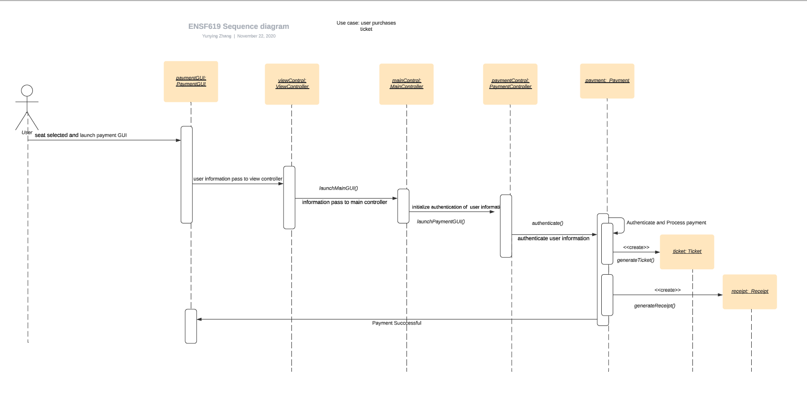Diagram #3, Prepared by Yunying Zhang, use case: user purchases a ticket

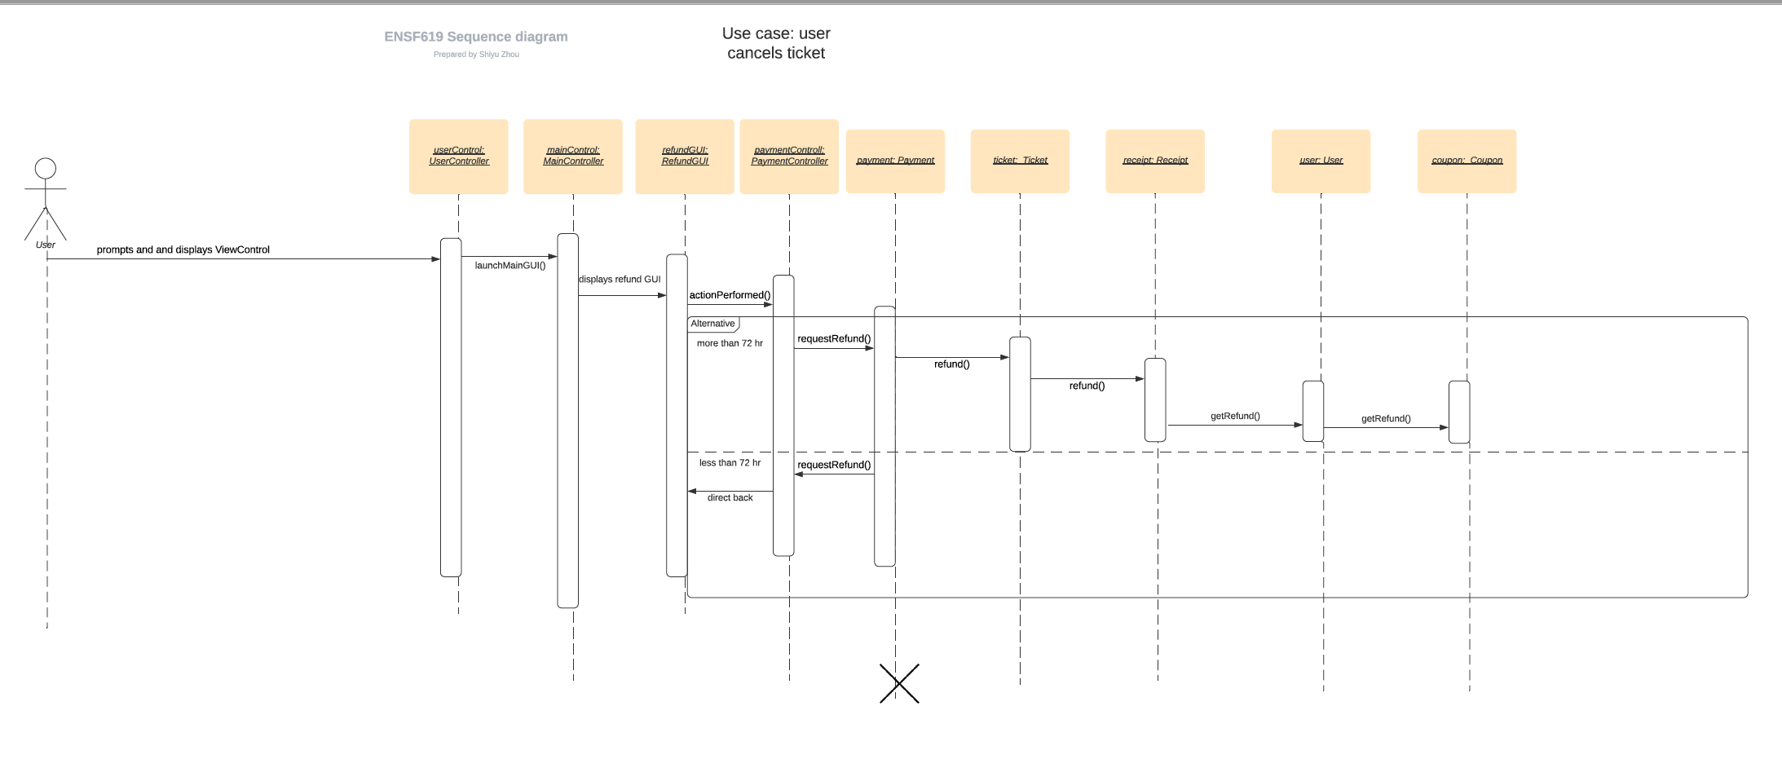Diagram #4, Prepared by Shiyu Zhou, use case: user cancels a ticket

**Section 7 State Transition Diagram**

For ticket object:

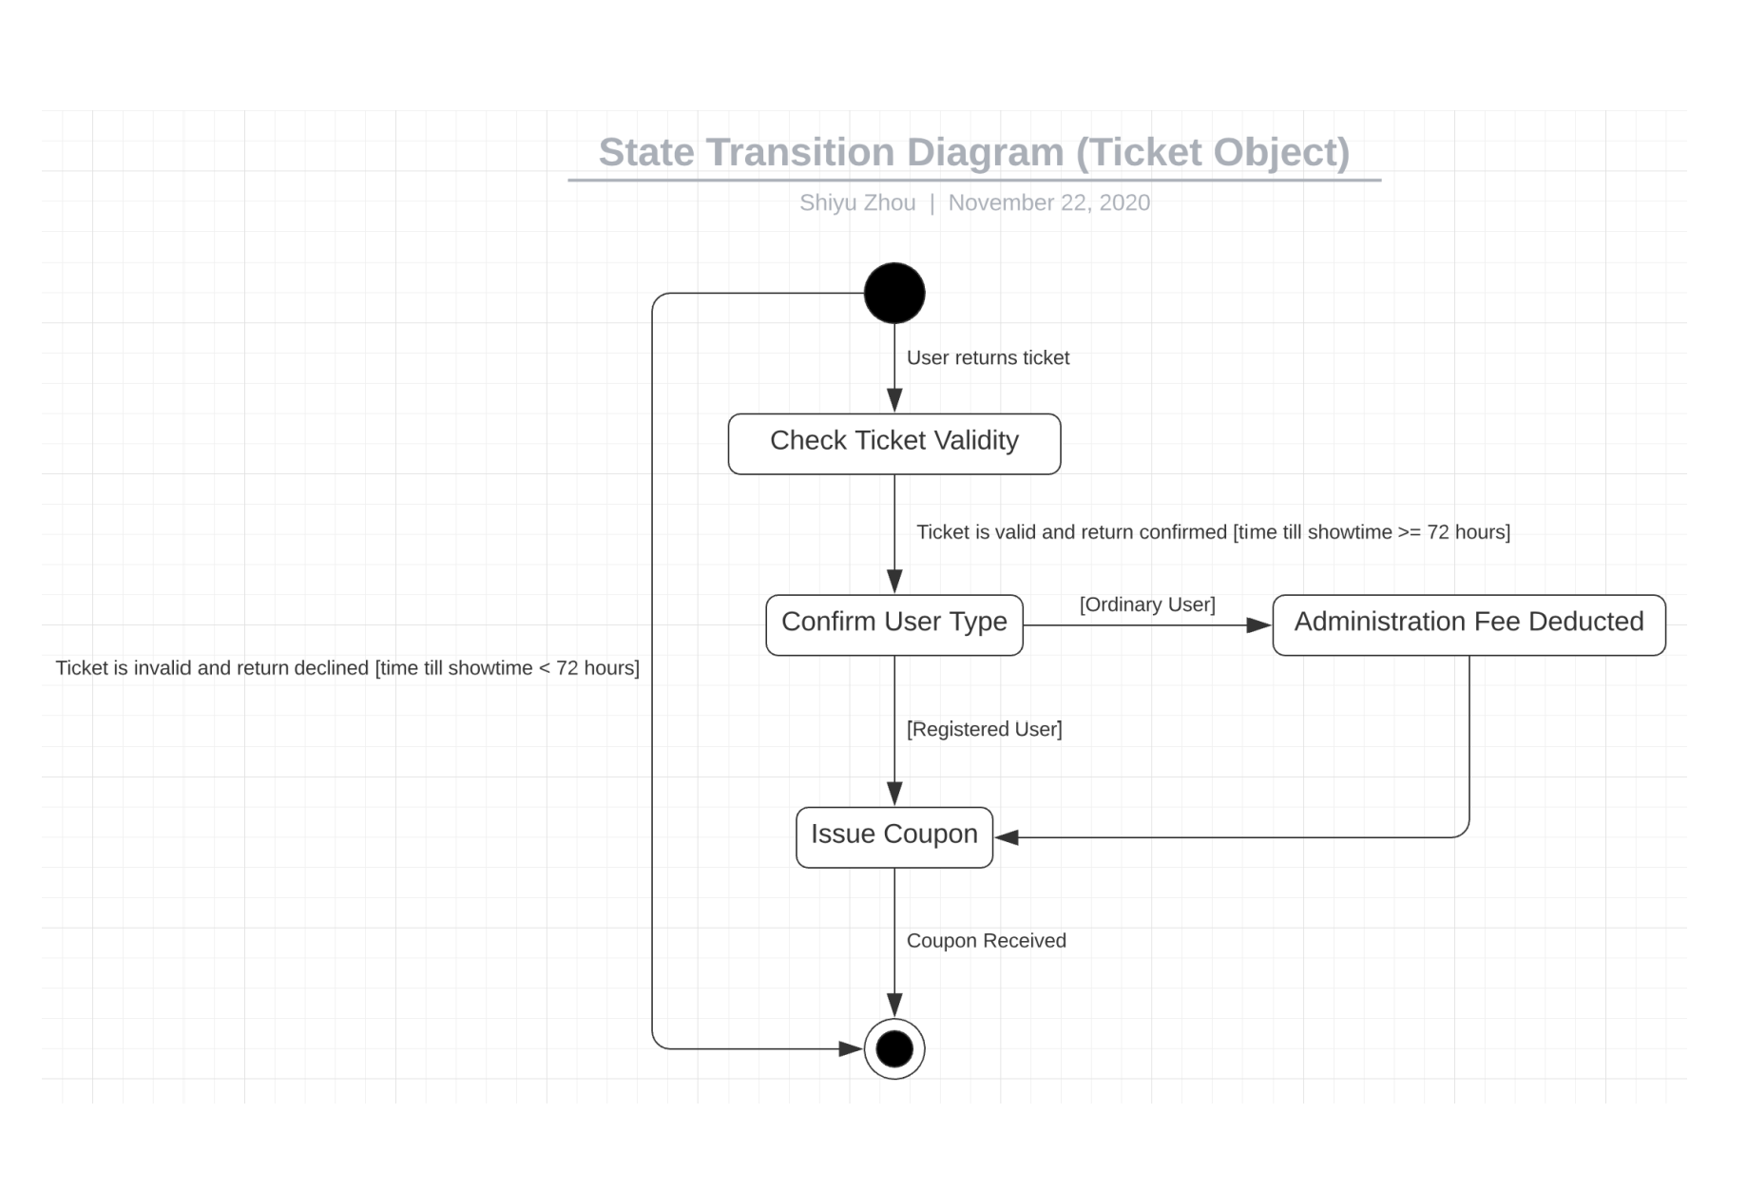

For Payment object:

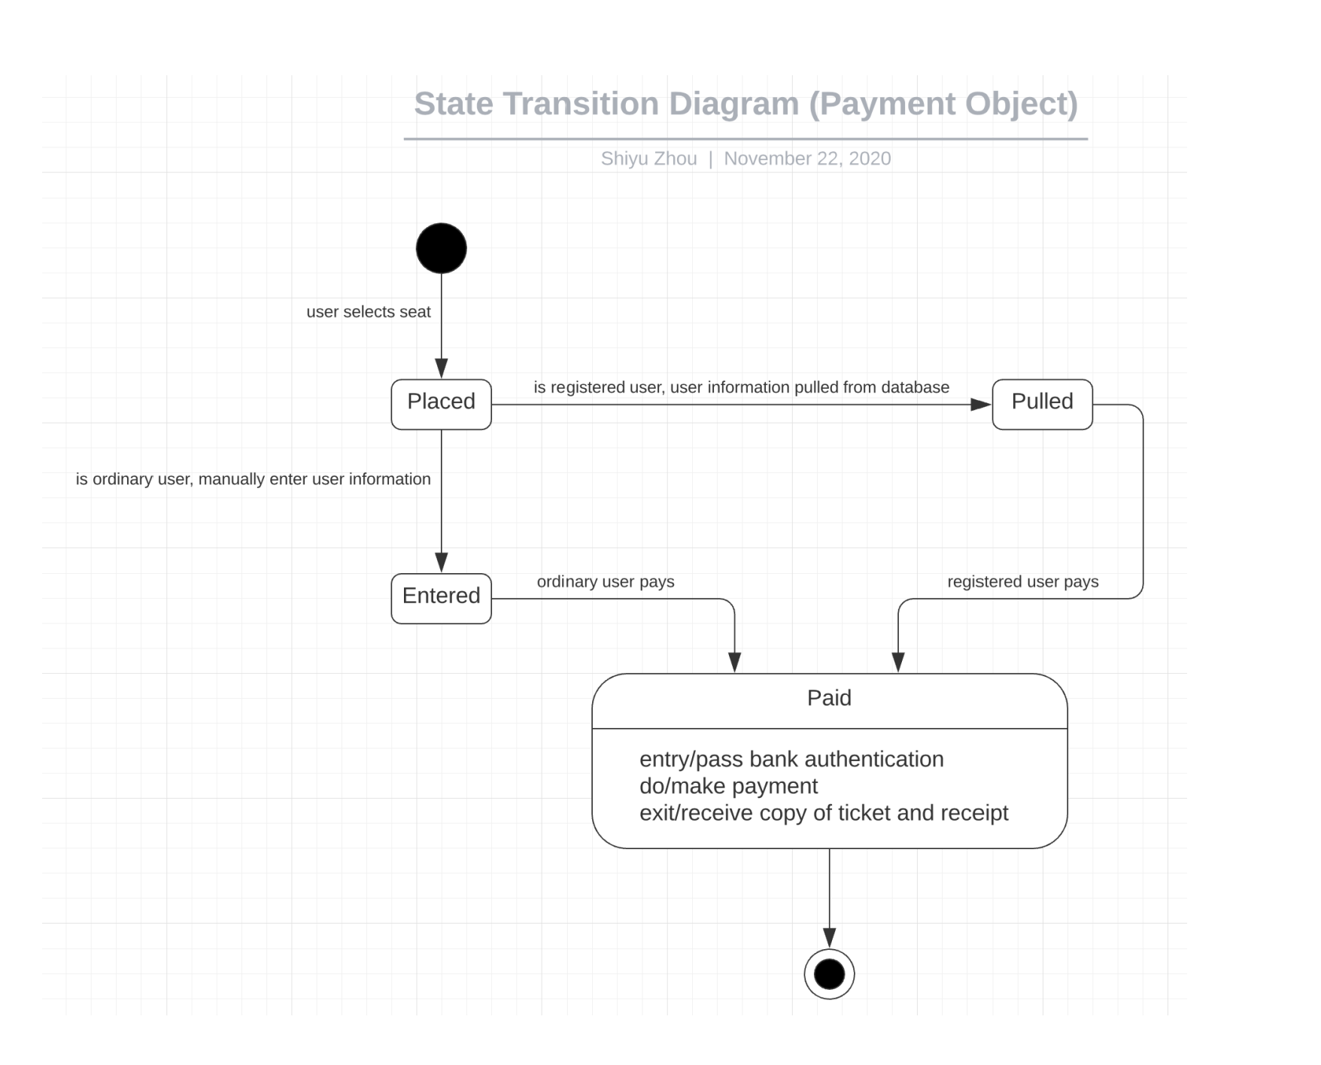

**Section 8 System Activity Diagram**

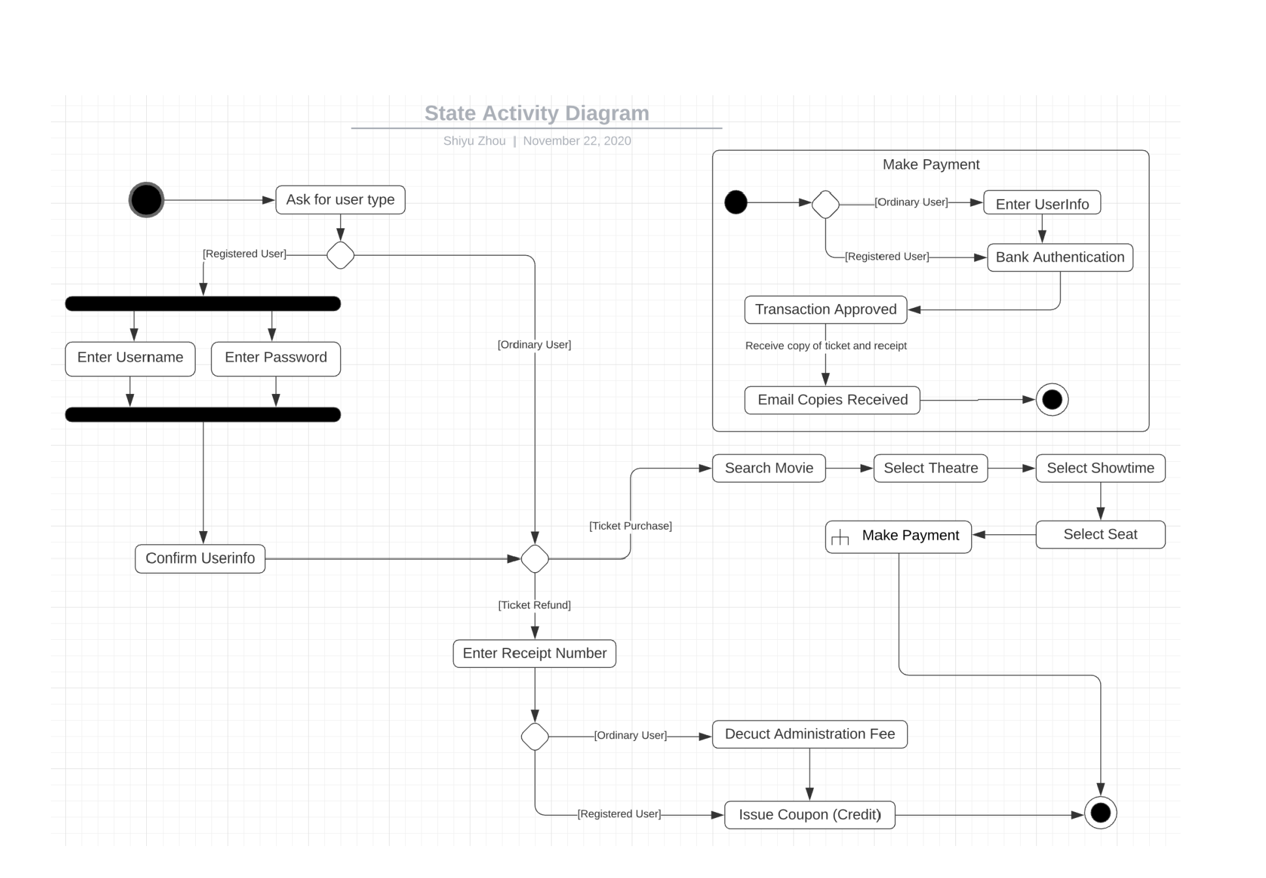

**Section 9 System Package Diagram**

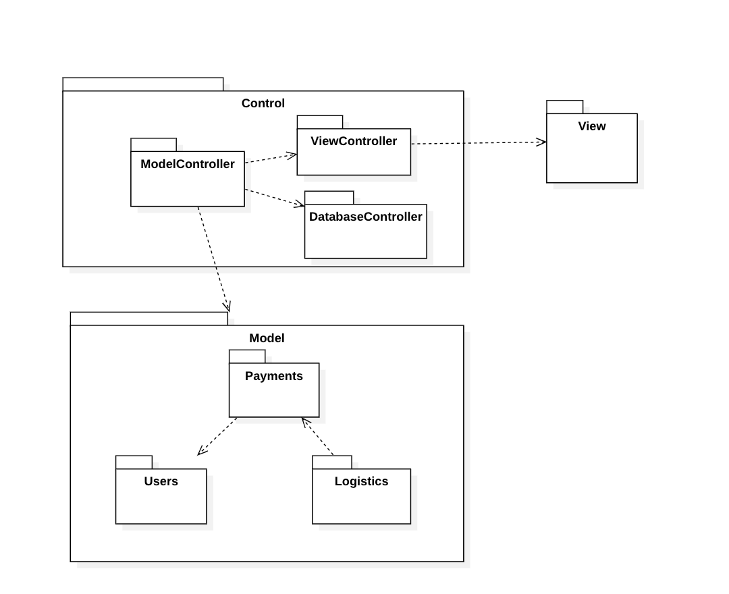

**Section 10 System Deployment Diagram**

